Relative Motion
- Read the scenario and write a statement that accurately describes the student’s motion: A student is sitting in a moving school bus. Through the bus window, the student sees a fire hydrant at an intersection pass by and out of sight as the bus travels down the road.
________________________________________________________________________________________________________________________________________________________________________________________________________________________________________________________________________________________________________________________________________________
- Now that you know more about relative motion, re-write your statement:
________________________________________________________________________________________________________________________________________________________________________________________________________________________________________________________________________________________________________________________________________________
Position vs Time
- Open the PhET simulation The Moving Man: http://bit.ly/TheMovingMan
- Under the Introduction tab, have students drag the man to the left. What do notice happened to the Position value? Drag the man back to the right. Explain why sometimes the Position value is sometimes positive and sometimes negative.
________________________________________________________________________________________________________________________________________________________________________________________________________________________________________________________________________________________________________________________________________________
- Explain the motion of the man using the terms relative motion (or the motion is relative to…) and reference point.
____________________________________________________________________________________________________________________________________________________________________________________________________________________________________________________________
- Click on the Charts tab and close the Velocity and Acceleration graphs by clicking the beside each one. Observe the graph when they move the man to the left, to the right, fast, and slow. What do you notice when you move the moan to the right? To the left? Fast? Slow? What happens when he is sitting still?
__________________________________________________________________________________________________________________________________________________________________________________________________________________________________________________________________________________________________________________________________________________________________________________________________________________________________________________________________

- Making observations. Take the moving man through a series of scenarios. Observe and recreate the graphs for each scenario.
A man standing still at 4m.
-5
-10
5
0
10
Time
(s)

Distance (m)
A man moving from 0m to 10m at a fast pace.

-5
-10
5
0
10
Time
(s)

Distance (m)
A man moving from 0m to 10m at a slow steady pace.

-5
-10
5
0
10
Time
(s)

Distance (m)

A man moving from 0m to -10m at a slow steady pace.

-5
-10
5
0
10
Time
(s)

Distance (m)
A man moving from 0m to 5m at a slow steady pace, then moving back to 0m at a slow steady pace.

-5
-10
5
0
10
Time
(s)

Distance (m)
A man moving from 0m to 10m at a slow steady pace, then moving back to 0m at a fast pace.

-5
-10
5
0
10
Time
(s)

Distance (m)

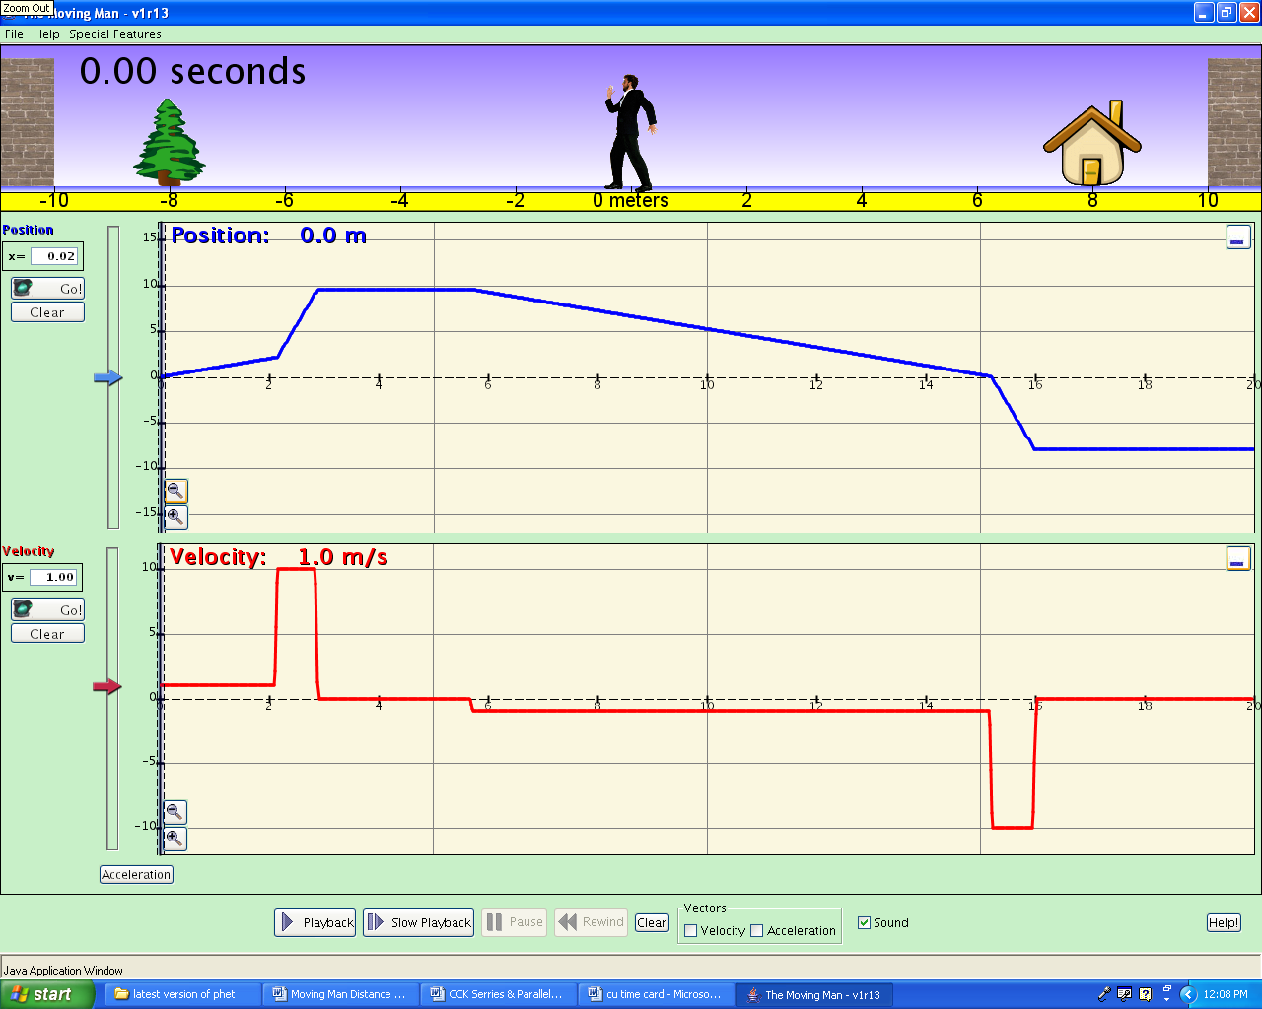
- Apply what you learned. Look at the graph below and for the different parts of the graph that are marked write a statement about what is happening. Be sure to include the direction of motion and the speed of motion.
Part A
Part B
Part C
Part D
Part F
Part E

Part | Description of direction and speed

